Session 17 Weekly Assignment:

**Home Page:**

Main Page with NavBar and the scoreboard using Material UI and CSS

When the user selects the name of the player, the detail card will appear with the date of creation and updated date

When the user adds a score by pressing the + button, the score increase and the date will be updated to today’s date. At the same time, the total point will change at the top left-hand corner.

Users can Add a Player at the input field below and the player's name will capture on the scoreboard. Scorecard will be created as well. The default point will be zero and the number of players on the top left will be updated to “4”

The player can delete the player name on the x button highlighted at the left of the player’s name

Once the previous player’s name is deleted, the total player will reflect the number to 3 again

**Features Page**

Users are able to navigate to the Features page and see the list of Professional Players. Data is fetch on API and displayed to this page. On the side note, the photo shown below is the data displayed in Mobile App.

**About Page**

The About Page shows the images of the Liverpool Football team along with the word description on top of the photo. The carousel is imported from react-bootstrap. Again, images below show the mobile view of the carousel



The Hamburger Icon shows the route of other pages that user can navigate

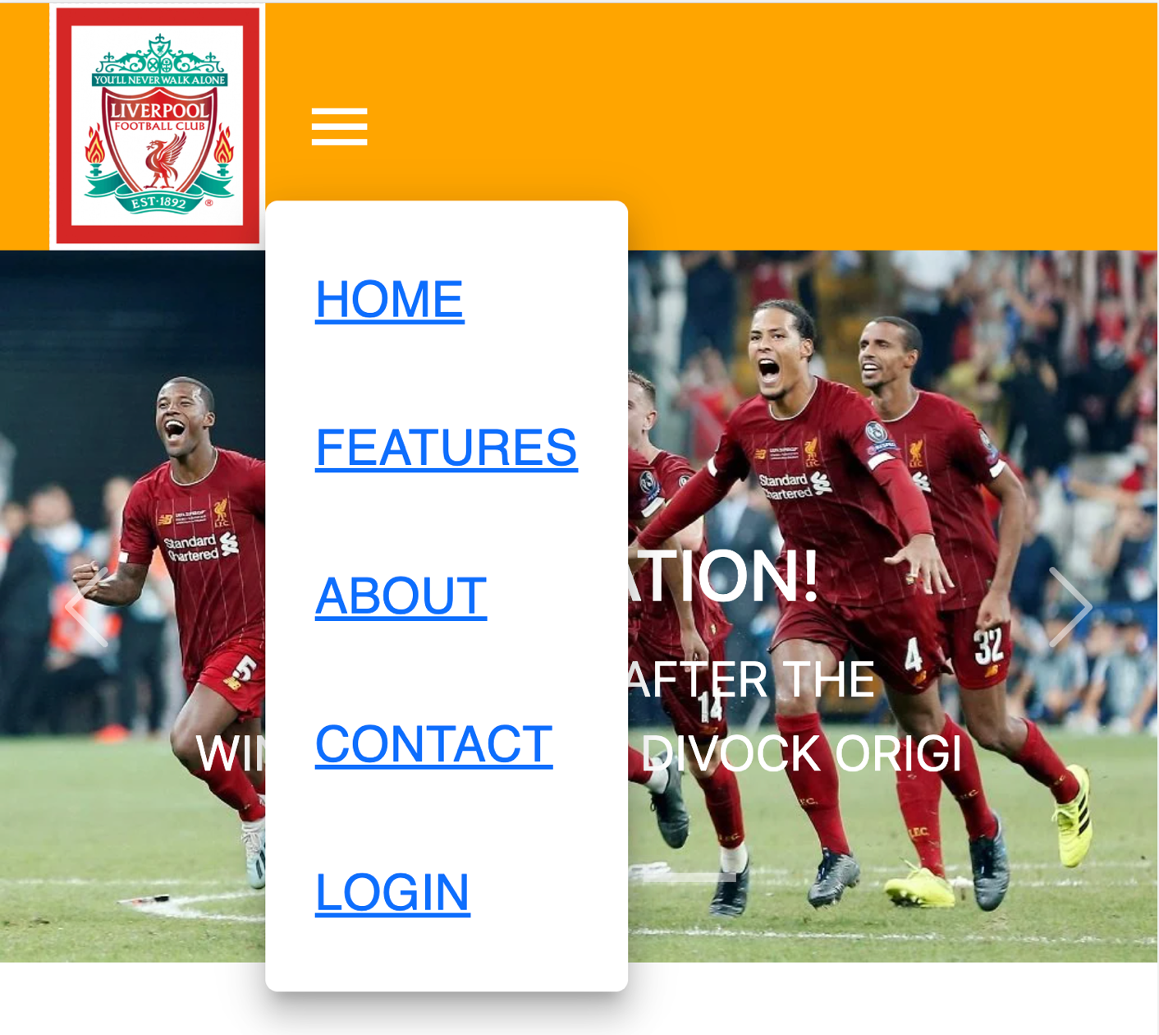

**Contact Page**

User can register their interest in the contact form. Form shows the fail validation if user did not key in any details

If user did not input the correct email format

If the user did not input any messages in the message box

**Login Page**

Login Form import from react-bootstrap

If user did not key in proper email address

